I2C/ SMBus Communication Protocols

Alejandro Pantoja-Zurita
Delaware Technical Community College
CSC 210: System Programming
Instructor: Tian Z. Ding
November 9th, 2025
Table of Contents
List of Figures ………………………………………………………………………………….... 3
Introduction ……....……………………………...……………………….…………………...…. 4
Interfaces ……...…...……………….……………………...……….….........…....……… 4
I2C (Inter-Integrated Circuit) Bus ………….…………………………………...………...…...... 5
History ……...…...……………………………………...….……….…........…...……..… 5
Structure & Operation .……...………………...……...……………...…………………... 5
Data Transfer Protocol .……...…………………...………..........…...…………………... 7
SMBus (System Management Bus) ………….…………………………………...………....…... 8
History ……...…...……………………………………...….……….…........…...……….. 8
Structure & Operation .……...………………...……...……………...…………..………. 9
Data Transfer Protocol .……...…………………...………..........…...…………………. 10
i2C vs smBus ………….…………………………………...…………………………………... 11
Conclusion ………….……………………………………...…………………………………... 11
References …….………...………………………………...………………………….…...……. 13
List of Figures
Figure 1: Computer /Human Interface …………………………………………………...……… 5
Figure 2: I2C Bus Communication ……………………………………….……………...……… 7
Figure 3: I2C Data Transfer Protocol …………………………………………………....……… 8
Figure 4: SMBus Data Transfer Protocol ……………………………………..………..……… 10
Introduction
Interfaces
As a software engineer, one of the most vital concepts to understand is the concept of interfaces. An interface can be described in many ways depending on the discipline, which can make understanding the fundamental concept challenging. The Britannica Dictionary defines interfaces as the place or area at which different things meet and communicate with or affect each other. (Definition of Interface 2025). Interfaces are a way of bridging the gap and establishing a communication line between two regions. In relation to computer systems, interfaces can be broken down into three unique regions that allow computers to communicate with one another, as well as humans. Robert Elder created a real-world example of interfaces in an attempt to describe interfaces through what He refers to as the ‘system’ and the ‘environment’ (Figure 1.) There exists a physical layer that connects regions together. Following that, a protocol layer established communication between regions. Lastly, the logical layer, which helps maintain organization as information is transfer between regions. (Tribble & Korpman, 1995) Without in concept of interfaces, interactions between computers and humans reverts to a more primitive state that removes control and limits the potential of computers. Through interfaces, humanity has been able to accomplish incredible feats throughout history and we continue to do so today in a wide range of industries including automotive, medical, and agriculture. With a firm understanding of what an interface, this paper will now focus on two commonly used serial communication interfaces. Among various communication interfaces, serial protocols like I2C and SMBus are widely used when communicating between devices. The goal of the paper is to identify why these two communication interfaces, or protocols are so popular in the world of computing. We will first look over the I2C interface, as it was the first to be created, followed by the SMBus.
Figure 1: Computer/ Human Interface
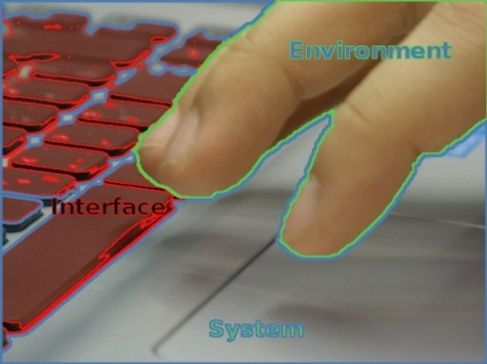
I2C (Inter-Integrated Circuit) Bus
History
The I2C (Inter-Integrated Circuit) bus is referred to by several name; I-squared-C, I²C, or IIC. It was originally developed by Philips Semiconductor (now NXP Semiconductors) in 1982 for the television industry. (I2C – what's that? 2025) It originally became popular due to its simple and efficient serial communication protocol. Since its introduction there have been several revisions that have increased its performance from an initial speed of 100 kHz up to 5 MHz with an ultra-fast mode. Allowing it to become a popular and commonly adopted communication protocol for many electronic devices outside of its initial purpose. It is now used by every major semiconductor manufacturer. It is suitable for use over short distances – approximately 1 meter @ 100 kilobaud (kBd).
Structure & Operation
I2C devices have 4 pins; power, ground, data, and clock pins. Each device that is connected to the I2C bus has a unique address that helps identify it to the ‘master’ device; Due to device addressing, no chip select (CS) pin is required, reducing the number of pins needed to communicate. It is capable of communicating with up to 128 devices using 7-bit addresses or up to 1024 devices using 10-bit addresses. (I2C Part 1 - Using 2 Arduinos 2019) Furthermore, the I2C’s communication protocol makes it capable of communicating between devices using only two wires, aside from the power line and the ground line; The two data lines used to communicate are the Serial Clock Line (SCL) and the Serial Data Line (SDA). The SCL line is unidirectional and carries the clock signal, generated by the ‘master’ device, that ensures synchronicity between the ‘master’ and ‘slave’ devices. Meanwhile, the SDA is a bidirectional line used to transfer data between devices. Both lines are open drain, meaning devices on the bus cannot actively drive the lines high (the default state between devices), they can only pull the line low to represent low logic (0), in order get back to high logic (1) an external pull-up resistor is required to restore the lines back to the bus’s supply voltage level (VDD) when there is no device pulling them to low. This line is commonly 3.3 or 5 volts depending on the voltage of the ‘master’ device. (Figure 2.) This paper focuses on the I2C bus; however, it is important to note that there are other communication protocols which allow for communication between devices using only one line; however, the I2C bus offers a synchronous communication protocol that allows for better error handling than a simple one-line communication protocol. The synchronous communication protocol requires that data be transferred in sync with the clock speed. The SCL line is the clock signal which synchronizes the data transfer between the ‘master’ device and the ‘slave’ device, it is generated by the ‘master’ device. Each data bit is transferred during each clock pulse.
Figure 2: I2C Bus Communication
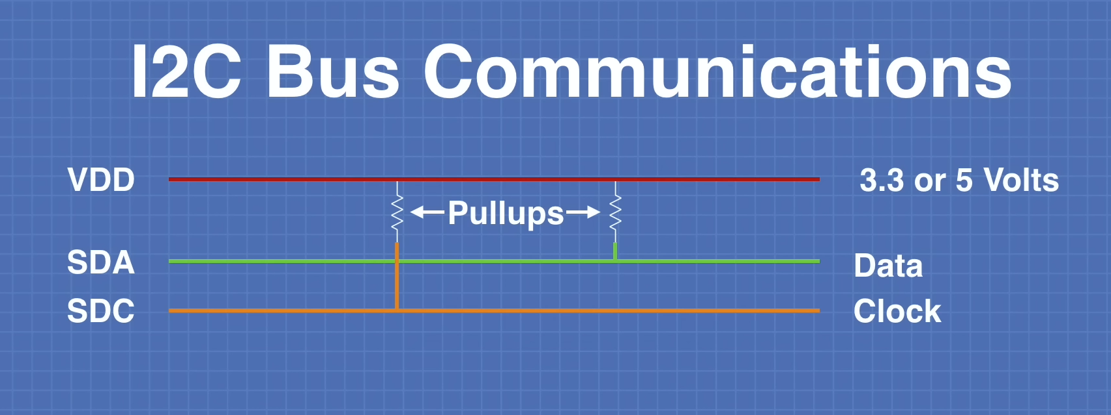
Data Transfer Protocol
Data is transferred in 8-bit sequences, each followed by an acknowledge (ACK) bit from the ‘slave’ device; this helps with error handling. Communication between devices is initiated with a start condition from the ‘master’ device; The SDA line is low logic while the SCL is high logic. Once the start condition has been sent, the ‘master’ device sends a 7-bit address and a read/ write bit to the ‘slave’ device depending on what it wants to do. The ‘slave’ device then acknowledges if it received the information; Both the SDA line & SCL line are low logic. If the ‘slave’ device does not acknowledge (NACK) the data, the SDA line is high logic – which signals an error or that it cannot accept more data. In the event of a NACK, it is up to the master device to determine how it proceeds. If the data is acknowledged, the ‘master’ device sends out another 8-bits of data is sent containing the internal registry address for the ‘slave’ device. This is followed once again by a acknowledge bit. Upon completion, data can begin transferring between devices, 8-bits at a time followed by an acknowledge bit. The total data size determines the amount of time the 8-bit data sequence transfer occurs. Once its all been set, a stop condition bit is sent to finalize the interaction between the ‘master’ and ‘slave’ devices; Both the SDA and SCL lines are high logic. (How I2C Communication Works and How To Use It with Arduino 2015) The I2C does have slower transmission speeds in comparison to other communication protocols as a result of the device address bits and ACK bits, however this help make the I2C flexible and modular while helping to reduce the amount errors in comparison. I2C is a versatile interface that allows computers to communicate with a broad range of electronics, Looking ahead, we will now focus on the SMBus, a subset of the I2C communication protocol.
Figure 3: I2C Data Transfer Protocol
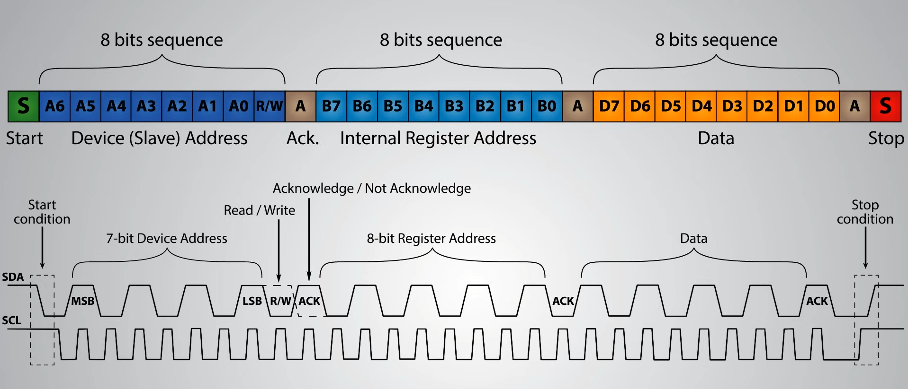
SMBus (System Management Bus)
History
The System Management Bus (SMBus) was developed by Intel and Duracell in 1994-1995 as subset of the I2C communication protocol with added features that focused on efficient low bandwidth communication between devices. These features included enhanced error detection and power management; Intel determined that there was a need to extend the functionality of their chipset and attach batteries to systems while developing hand held and mobile devices. (Hopkins, 2021) Using the I2C bus as the starting point due to the I2C bus’s low speed, the SMBus was developed. As a result, it shares the same physical layer. It takes advantage of the 12C’s core operations including device addressing, start and stop conditions, and low pin count. Intel modified the bus’s electrical characteristics to meet the requirements of battery-powered systems. Today, the SMBus is used as a means for system component chips to communicate between each other within a system. More specifically, it allows for batteries to communicate with other system components such as the CPU or other power related components. Its simplicity, compatibility, and standardized communication protocol allow for easy integration and communication between various low speed devices. SMBus is commonly used in computer motherboards for system management tasks, it is also used to communicate with devices, including switches, temperature sensors, and smart batteries
Structure & Operation
In an SMBus system, each device is assigned a unique device address using the familiar addressing system of I2C. There is a difference with how devices may interact with one another; any device may be addressed by any other device in order to assume the role of ‘master’ or ‘slave’ for any particular interaction. In addition to the typical ‘master’ and ‘slave’ roles in I2C communication, SMBus introduces a third role: the host. A host serves as a special ‘master’ interface to the CPU; however, this is third device role is optional and not required in simpler systems. This addition allows the SMBus to supports Address Resolution Protocol (ARP) for dynamic address assignment; If the host detects two devices with the same slave address, the ARP process will dynamically assign a new unique address to the ‘slave’ devices. ARP allows these devices to be used immediately, without the need to restart the system entirely. SMBus also uses two dedicated communication lines to transfer data, just like I2C; Serial data (SMBDAT) and serial clock (SMBCLK). Both of these lines are bidirectional, unlike I2C. This enables any device to act as the ‘master’ and transmit the clock signal to the ‘slave’ device for a specific data transfer. Just like I2C, multiple masters can exist within an SMBus at a time; Only one ‘master’ is capable of controlling the bus at a time. Arbitration ensures conflict resolution if two devices attempt to take the role of ‘master’ simultaneously. (Hopkins, 2021) With regards to the electrical components, SMBus devices may be powered by the bus’s VDD or by an external power source; devices connected the communication bus as not required to share the same power as the bus, this differs from I2C. The key requirement for this is that any device’s I/O that is powered externally remain compatible with the SMBus voltage range and electrical specifications. These specifications are more precise in comparison to I2C in order to ensure consistent behavior in systems like motherboards or smart battery networks, where components may have independent domains but still need to communicate safely with other hardware.
Data Transfer Protocol
SMBus is capable of transferring data just like the I2C bus; transferring 8-bits of data at a time. The data packet contains an initial 7-bit address followed by a read/ write bit, it also contains start and stop bits, as well as ACK and NACK bits between the 8-bit packets. The SMBus does expand its capabilities by providing the option to add an alert signal, called SMBALERT, which allows devices to request attention from the host. SMBus also supports Packet Error Checking (PEC) to improve communication reliability. This is performed by adding a packet error code at the end of each message. (Hopkins, 2021)
Figure 4: SMBus Data Transfer Protocol
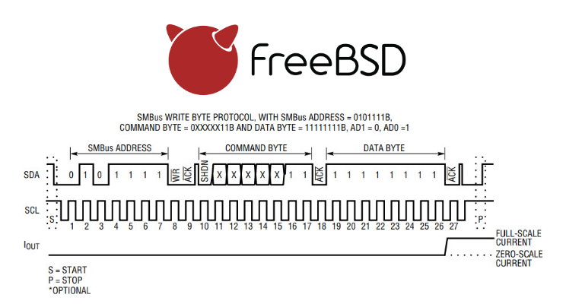
SMBus vs I2C
The two sections above identify the I2C bus and SMBus respectively. Since they use the I2C physical layer, they have a lot on common however they also have different capabilities. The SMBus includes additional features not available in I2C, allowing for more reliability and control of the connected devices. Meanwhile the I2C bus allows is less strict with its electrical requirements and more flexible, allowing for more general-purpose use. Aside from the items noted in the sections above, there are two main differences between the two communication protocols to keep in mind; there are difference with the timeout behavior and clock speed of these two communication protocols. In the I2C communication protocol, there is no established timeout value, meaning communication can hang indefinitely if a device holds the clock or data line low logic, there is no error recovery process included. The SMBus in comparison does include a timeout feature; if the clock line stays low for more than 35 milliseconds, the bus resets. This helps prevent communication from freezing permanently. (Differences Between SMBus vs I2C 2020) This also affects the clock speed as result; because the clock in an SMBUs system can time out, the system must prescribe a minimum clock speed to prevent timeouts. As a result, the SMBus defines both a minimum clock speed (10 kHz) and a maximum (100 kHz). I2C on other hand has not minimum clock speed, it currently supports five different modes: standard (100 kHz), fast (400 kHz), fast plus (1 MHz), high-speed (3.4 MHz), and ultra-fast (5 MHz). To summarize. the I2C provides more flexibility for general purpose communication, while SMBus prioritizes reliability, standardization, and safe operation in power-managed systems.
Conclusion
Interfaces allow engineers to extract the most amount of potential from devices, their impact on performance is tremendous. The specifications noted above highlight why the I²C and SMBus communication protocols play crucial roles in the world of computing. I²C is the preferred communication protocol due its versatility, low-pin-count for communication between sensors and microcontrollers. The SMBus extends those capabilities with enhanced error handling, and power management; making it indispensable in system-level applications where power management is necessary to obtain a high level of performance. Consumers are heavily reliant on technology that implements these interfaces, highlighting why these two types of interfaces are some of the most popular and commonly used today. Trends show that these interfaces are also expanding into the medical, industrial and automotive industries. (I2C Bus Market Growth & Innovations 2025–2035 2025) They may continue to rise in popularity due to their robust features, cost effectiveness, and versatility. Looking ahead, the interfaces may continue to be relevant for a while, as such, it benefits engineers to become familiar with these interfaces in order to extra the highest amount of performance possible when implementing these for future projects.

References
The Britannica Dictionary. (n.d.). Definition of Interface. Encyclopædia Britannica. https://www.britannica.com/dictionary/interface?utm_source=chatgpt.com
DroneBot Workshop. (2019a, March 30). I2C Part 1 - Using 2 Arduinos. YouTube. https://www.youtube.com/watch?v=PnG4fO5_vU4
DroneBot Workshop. (2019b, April 20). I2C Part 2 - Build a I2C Sensor. YouTube. https://www.youtube.com/watch?v=yBgikWNoU9o
DroneBot Workshop. (2019c, September 16). I2C with Arduino and Raspberry Pi - Two Methods. YouTube. https://www.youtube.com/watch?v=me7mhrRbspk
Elder, R. (2016, February 1). Interfaces - the most important software engineering concept. Articles On Linux, Command-line & Software Engineering. https://blog.robertelder.org/interfaces-most-important-software-engineering-concept/
Elinoff, G. (2020, June 5). Has the modern data center outstripped I2C and Smbus? I3C may be the answer - news. All About Circuits. https://www.allaboutcircuits.com/news/has-modern-data-center-outstripped-i2c-smbus-i3c-may-be-answer/
Future Market Insights. (2025, August 5). I2C Bus Market Growth & Innovations 2025–2035. Future Market Insights. https://www.futuremarketinsights.com/reports/i2c-bus-market
Hopkins, J. (2021, January 13). What is SMBus? Total Phase. November 9, 2025, https://www.totalphase.com/blog/2021/01/what-is-smbus/
How To Mechatronics. (2015, October 5). How I2C Communication Works and How To Use It with Arduino. YouTube. https://www.youtube.com/watch?v=6IAkYpmA1DQ&t=2s
Staff Writer. (2020, March 24). Differences Between SMBus vs I2C. Total Phase. November 9, 2025, https://www.totalphase.com/blog/2020/03/difference-between-smbus-i2c/
TechVedas .learn. (2018, November 17). I2C Protocol Tutorial | How I2C Protocol works. YouTube. https://www.youtube.com/watch?v=HGX457RA4IU&list=WL&index=31
Tribble, D. A., & Korpman, R. A. (1995). Interfaces between Computer Systems. American Journal of Health-System Pharmacy, 52(5), 524–528. https://doi.org/10.1093/ajhp/52.5.524

